
Inner Health Ministries Retreat Center
Newsletter V. 3 ----------- July – September 2006

Executive Director:
Dr. Cara Marker

Board of Directors:
Dr. Isabel Guadiz
Dr. Irene and Ken Kraegel
David Lanning
Dr. Cara Marker
Tim Marker
Frank Stretar

Advisory Board:
Kevin Burke, Esq.
Alan Januzzi
Jeff Leimgruber
Ray Marvar
Leslie Sinclair
Betsy Stretar
Gregg Wasilko

B U I L D I N G B E H A V I O R S D A Y C A M P
PROGRAM EVALUATION 2006
Our Building Behaviors Day Camp was a huge success!! During the week of August 7th –11th, sixteen families of children (ages six to 14 years of age) with a diagnosis of a pervasive developmental disorder (PDD) participated in the program. Building Behaviors Day Camp is a specialized behavioral-based treatment program for children with attention deficit/hyperactivity disorder (ADHD), oppositional defiant disorder (ODD), and pervasive developmental disorders (PDD, such as Autism/Asperger’s). At the treasure hunt themed camp, children learned about following directions, stress and anger management, social skills and daily living skills (e.g., hygiene, diet, exercise) in a week long treatment program. Caregivers also attended a daily workshop, which focused on teaching parents behavioral principles. During this workshop, caregivers were also taught the same skills their children learned throughout the day.
Preliminary results of the Building Behaviors Day Camp program are promising, given that parent perceptions indicated that the child’s overall aggression, anxiety, attention, and daily living skills improved during the program. Also, parents reported that they felt their child learned the needed skills to become better listeners, to follow directions, to calm down when they were upset, and to improve their nonverbal communication skills. Parents also felt that they learned the skills necessary to help their child follow directions, recognize when they are getting upset, and improve their social skills. Given the positive results, we plan to offer at least two Building Behaviors Day Camp programs next summer. To follow-up with these families, we also started a Building Behaviors After School Program, which is offered year-round to reinforce the skills learned at camp and to introduce new skills. Riveredge Medical Building has graciously provided space for us to run the program until we have secured the necessary funds for a more permanent location. Thank you to all our supporters, as we couldn’t have done this without you!

LOOKING FOR WAYS TO HELP???
We are always seeking caring and interested individuals who wish to invest their time and resources. Here’s our wish list for 2006:

- Camp volunteers
- Musicians
- Art therapists
- Nurses
- Art supplies
- Sports Equipment
- Pool tables
- Games
- Musical instruments
- Computers
- Stories and Testimonies

C A M P C O U N S E L O R ’ S
P E R S P E C T I V E
I feel so blessed to have spent my last week of summer as a counselor at the Building Behaviors Camp! I loved watching the friendships form, and each child grow in different ways throughout the week. Sharing positively and love with the kids were my primary goals throughout the week, and it was fun to see their responses. I felt that each aspect of the camp helped every child in different ways. In the gym, I loved seeing the children learn to play together, share, and resolve conflicts and at the rock-climbing wall, it was awesome to watch kids conquer their fears, gain trust in others, and build their confidence. I am so happy to have met all the children, and still think about them all the time!
-Erin, Camp Counselor/Behavior Therapist

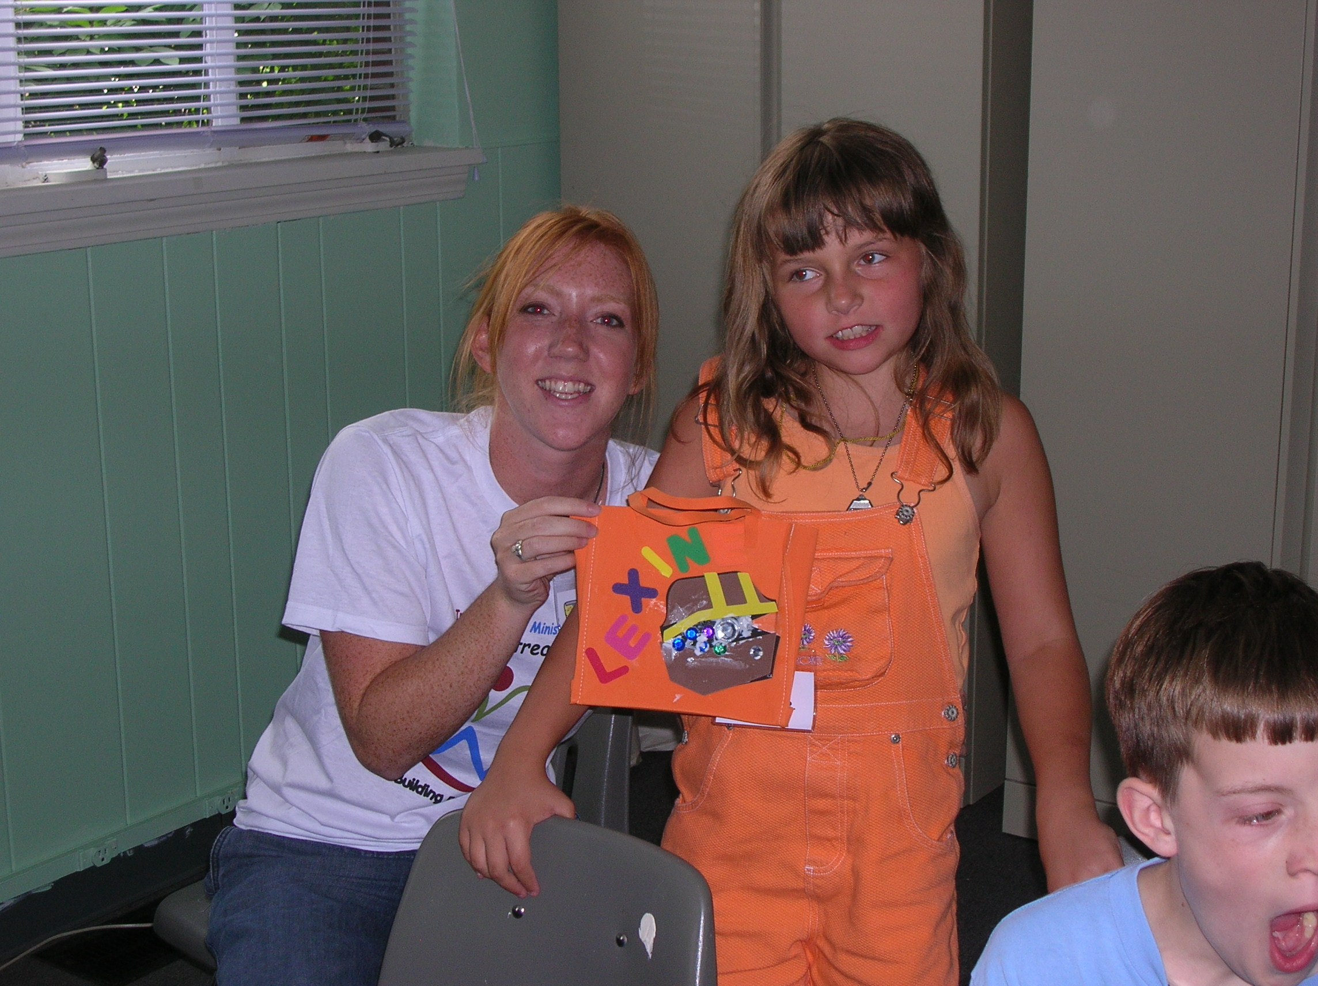

A W E E K I N T H E L I F E O F A C A M P E R
B U I L D I N G B E H A V I O R S D A Y C A M P : T R E A S U R E H U N T E R S 2 0 0 6

I had so much fun at camp this year!!! We pretended to be treasure hunters and got to earn gold coins, which we traded in for toys, games, and cool prizes in the treasure box! Every day we got to sing silly songs, act in a play, make cool crafts, eat great food, climb a rock wall, play games, go on scavenger hunts, and make new friends.

Day 1 - We learned about how to follow directions. This was important because we had to listen to our captain as we pretended to set sail for sea in search of lost treasure. I guess this was good for me to learn because my mom told me that I don’t listen very well. This is because I get too excited or distracted by noises around me. We got to make these cool treasure bags to put all our gold coins in. We got gold coins every time we did something good, like raise our hand, follow directions, or just be nice to someone.

Day 2 - We learned how to deal with being mad and stressed. During our treasure hunt, there was a huge storm, we were attacked by pirates, and then we were shipwrecked on an island! It was fun, although I think we were to pretend we were stressed and mad. I tend to get mad a lot at home and at school. We got a harmonica to learn how to belly breathe, which is supposed to help you relax.

Day 3 - We learned about how to talk to the islanders (since we were stranded on an island). I am not very good at talking to new people, especially other kids. I have a hard time starting a conversation and I get mixed up sometimes about what people mean when they say something. Also, people say I sometimes talk too loud or stand too close to them when I talk. I learned how to help with that.

Day 4 - We learned about how to eat healthy meals, how to exercise, and how to stay clean. During our “pretend” treasure hunt, we had not brushed our teeth or showered in days. We were also very hungry and had to climb up a big mountain to search for a King who had some kind of treasure. We got to sing silly songs about cleaning lint out of our belly buttons, brushing out teeth, and taking showers. It was funny!!! We also learned about eating healthy by bowling with coconuts.

Day 5 - The last day was the best. We made it to the King’s castle, who told us we could have all of his treasure. We were so excited, but also confused. Why would he give us all his treasure??? He then told us that his true treasure was in Heaven. He told us that God gave us one true treasure - His son, Jesus, who died for us so that we could live forever with Him in heaven. God’s love for us is supposed to be the real treasure. When you believe in Jesus, and are sorry for the wrong things you do, then you can become God’s child. They told us that this is a treasure that last forever. Gold and jewels are just temporary things here on earth. We made these really cool treasure chests and then put a verse from the bible in it. 1 John 4:9 - “This is how God showed his love among us: He sent his one and only Son into the world”.

Sports

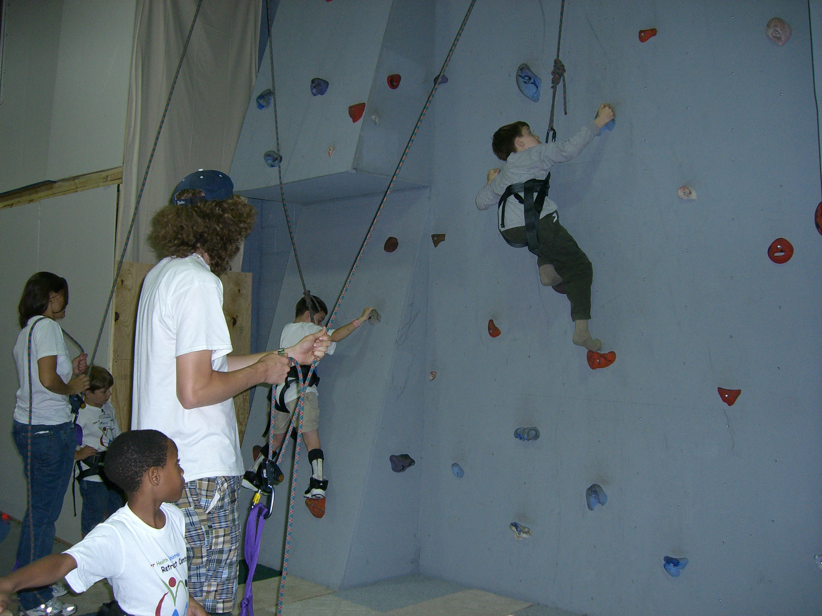

Music

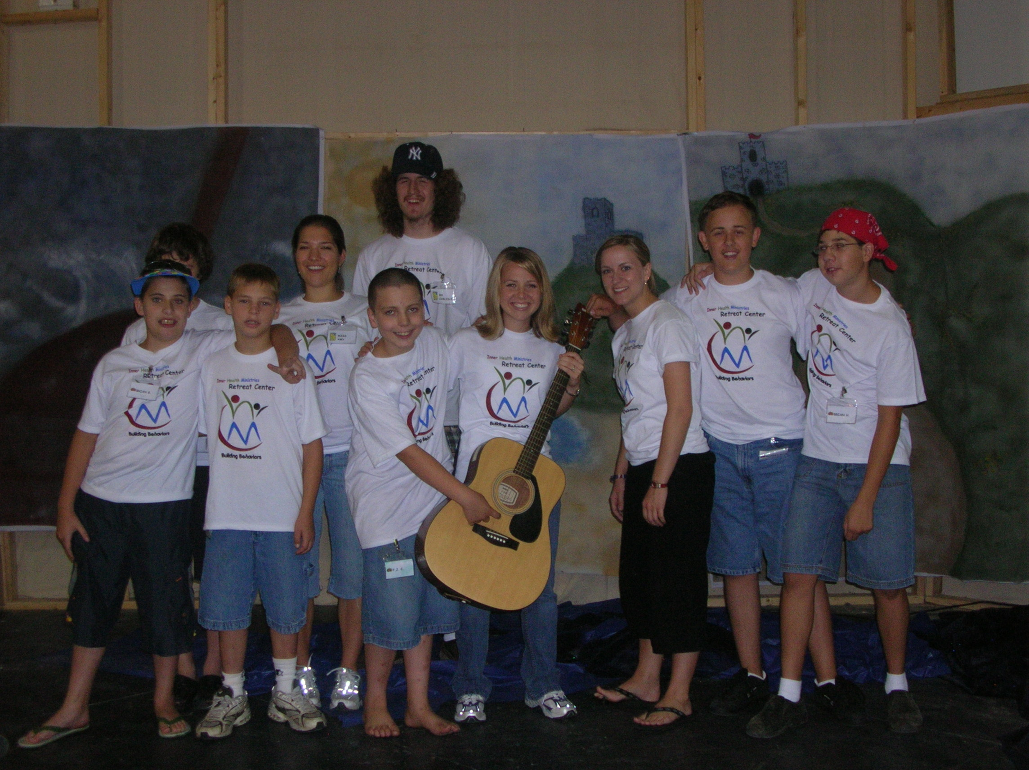

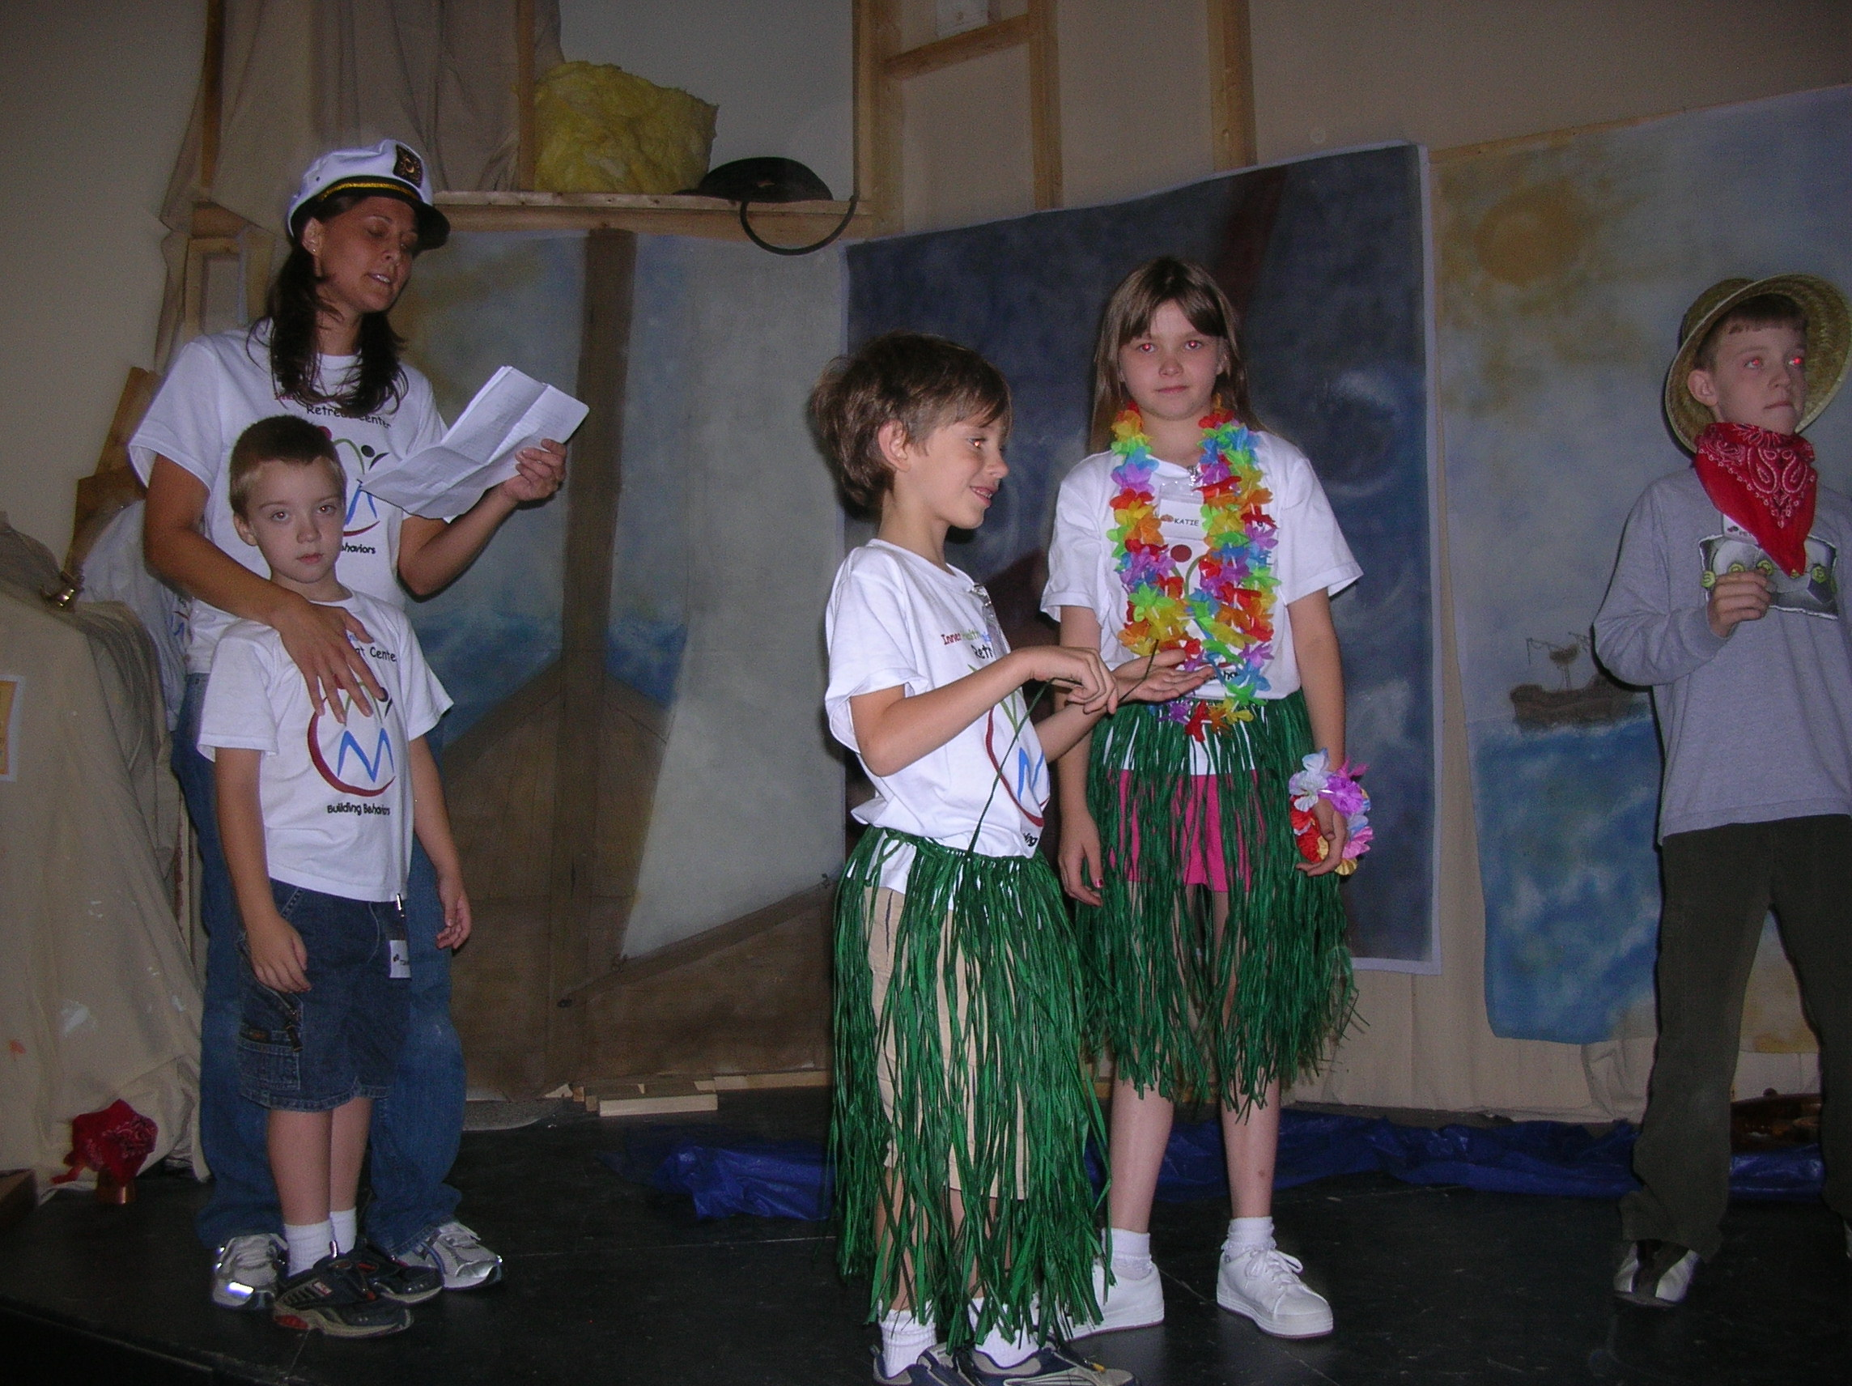

Drama

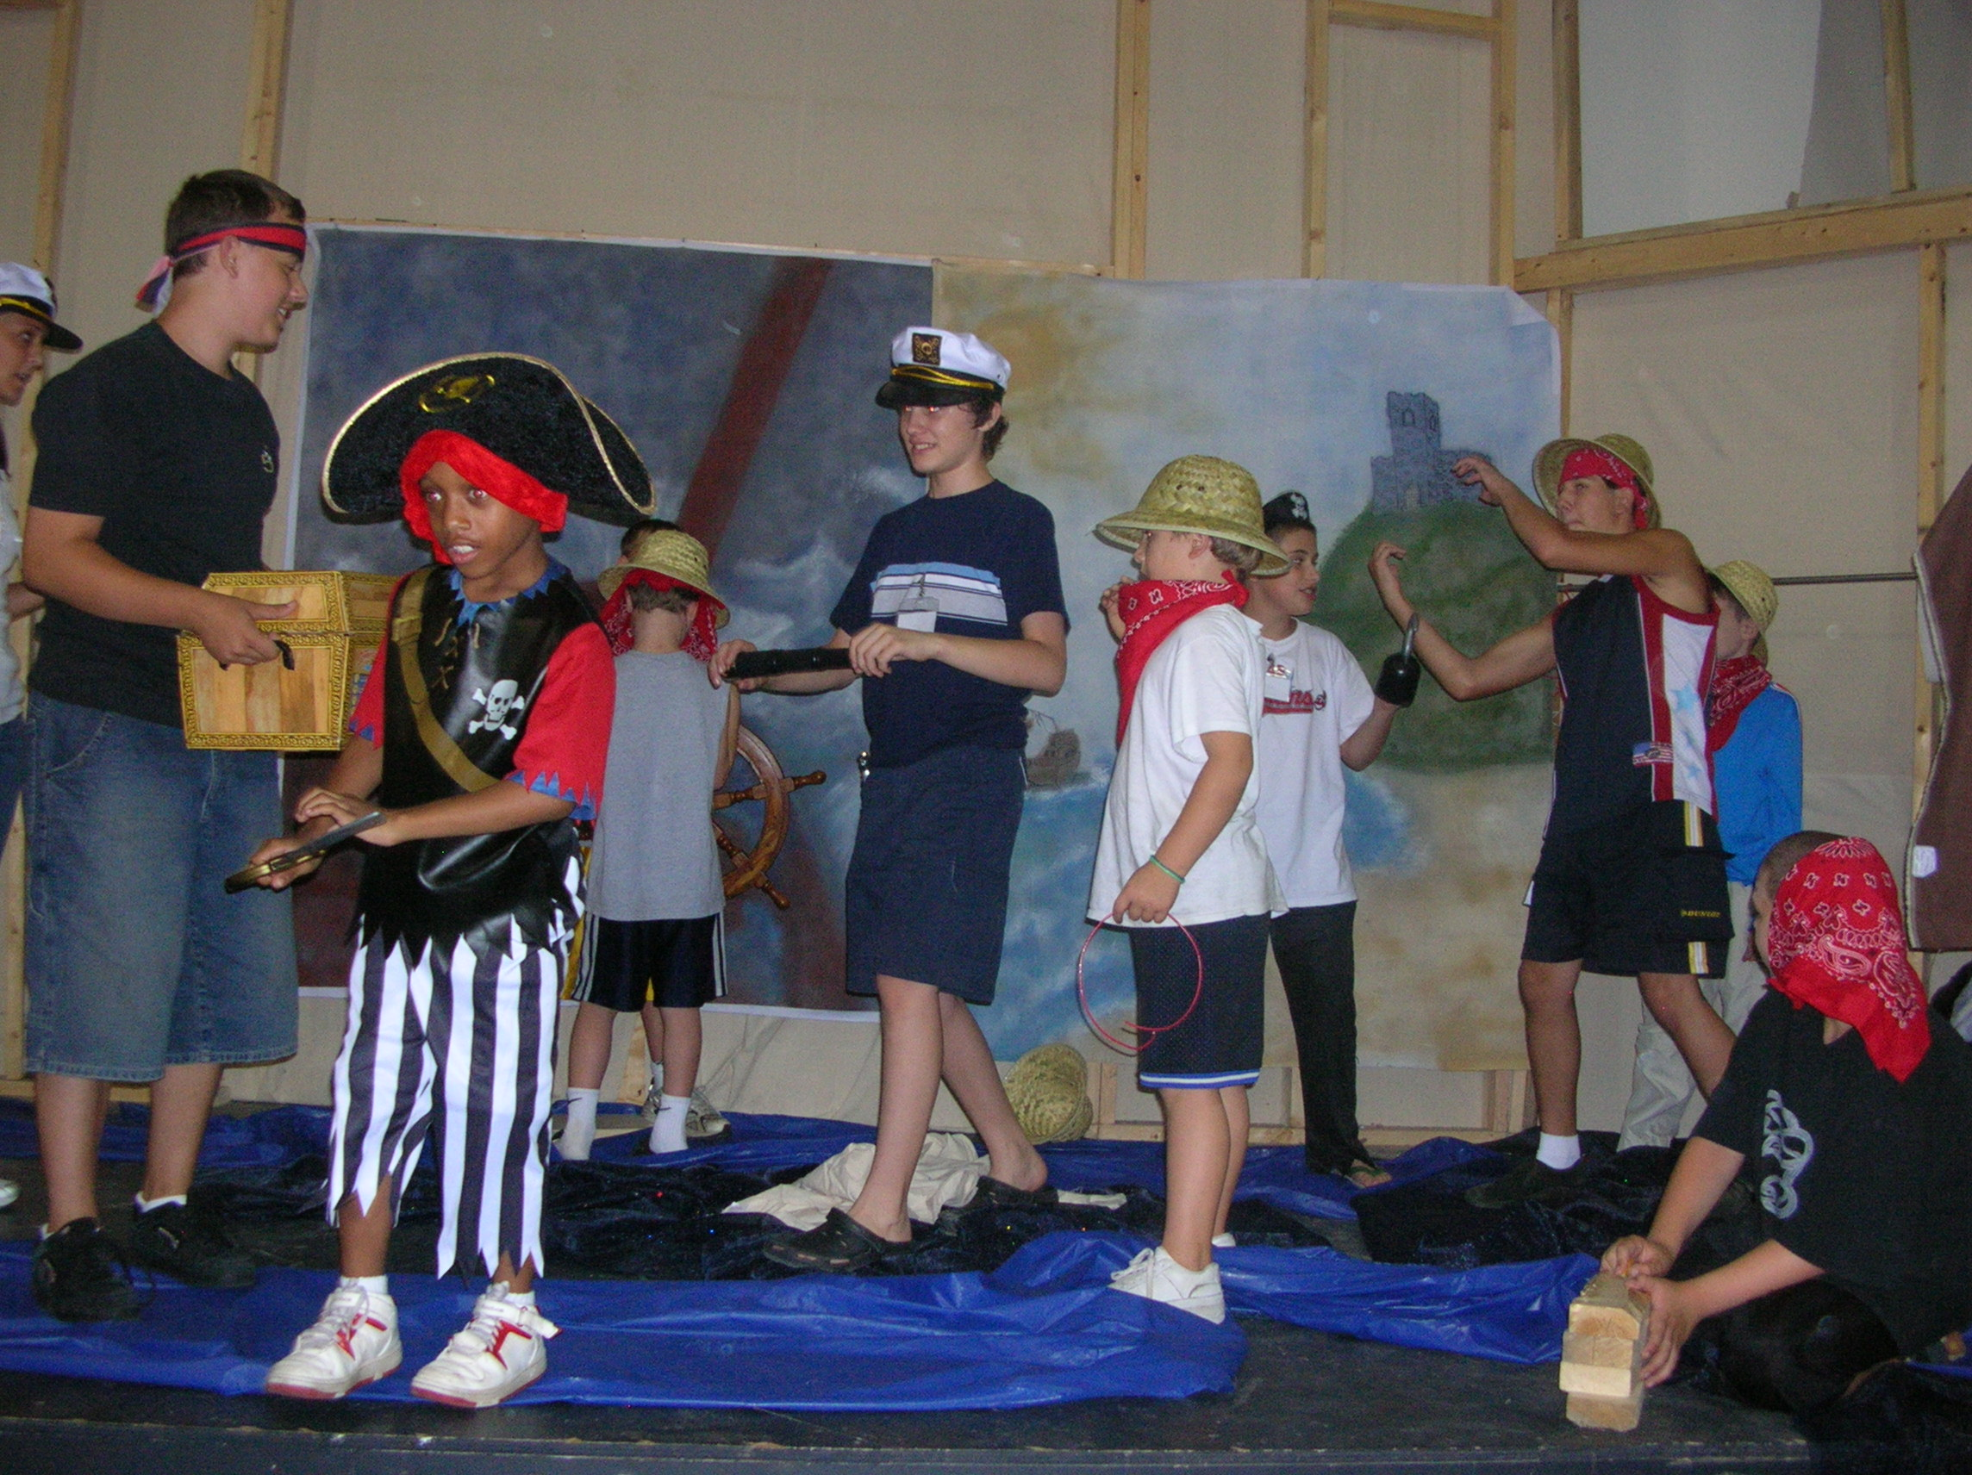

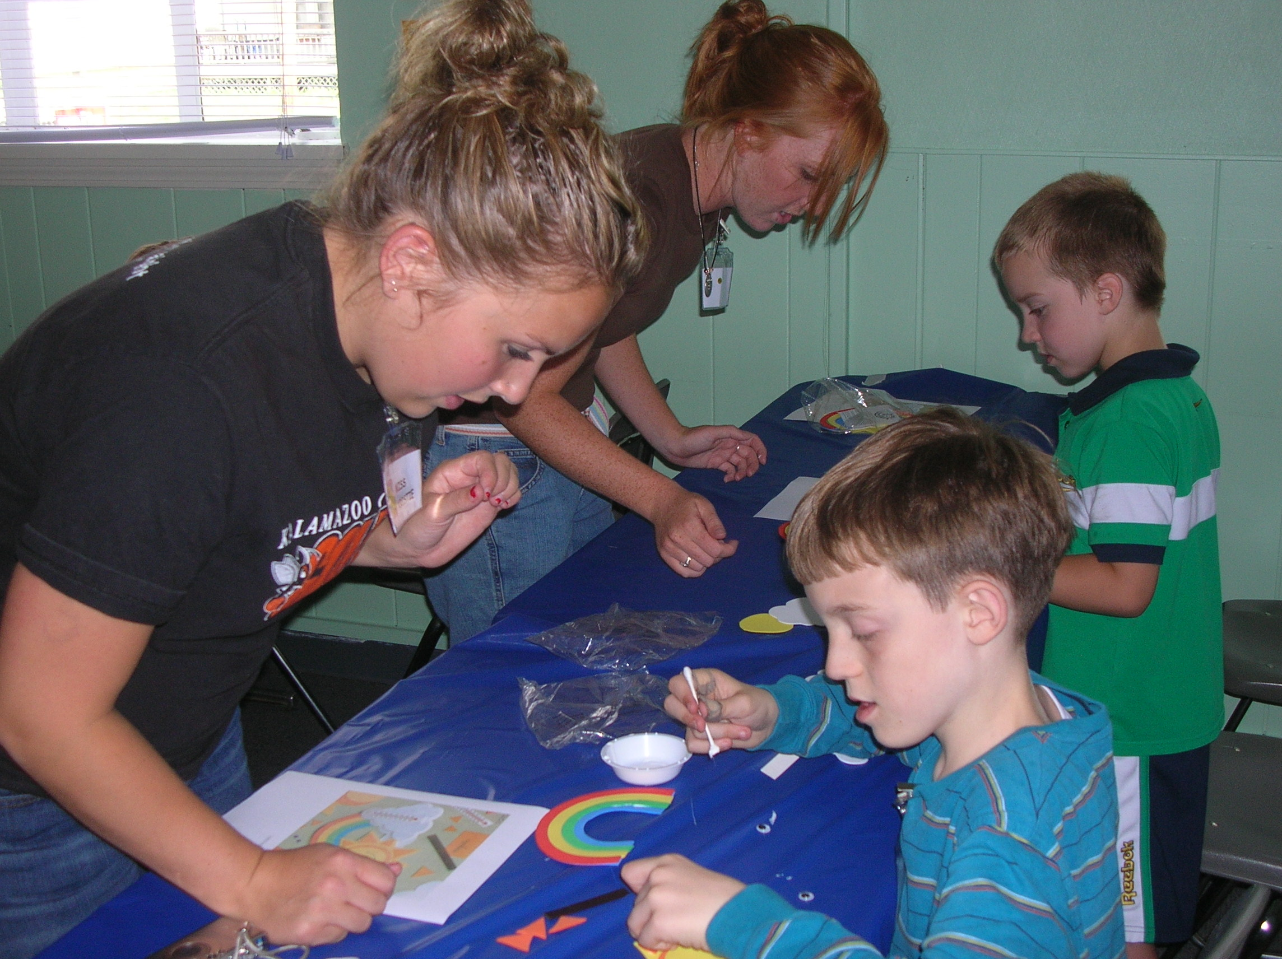

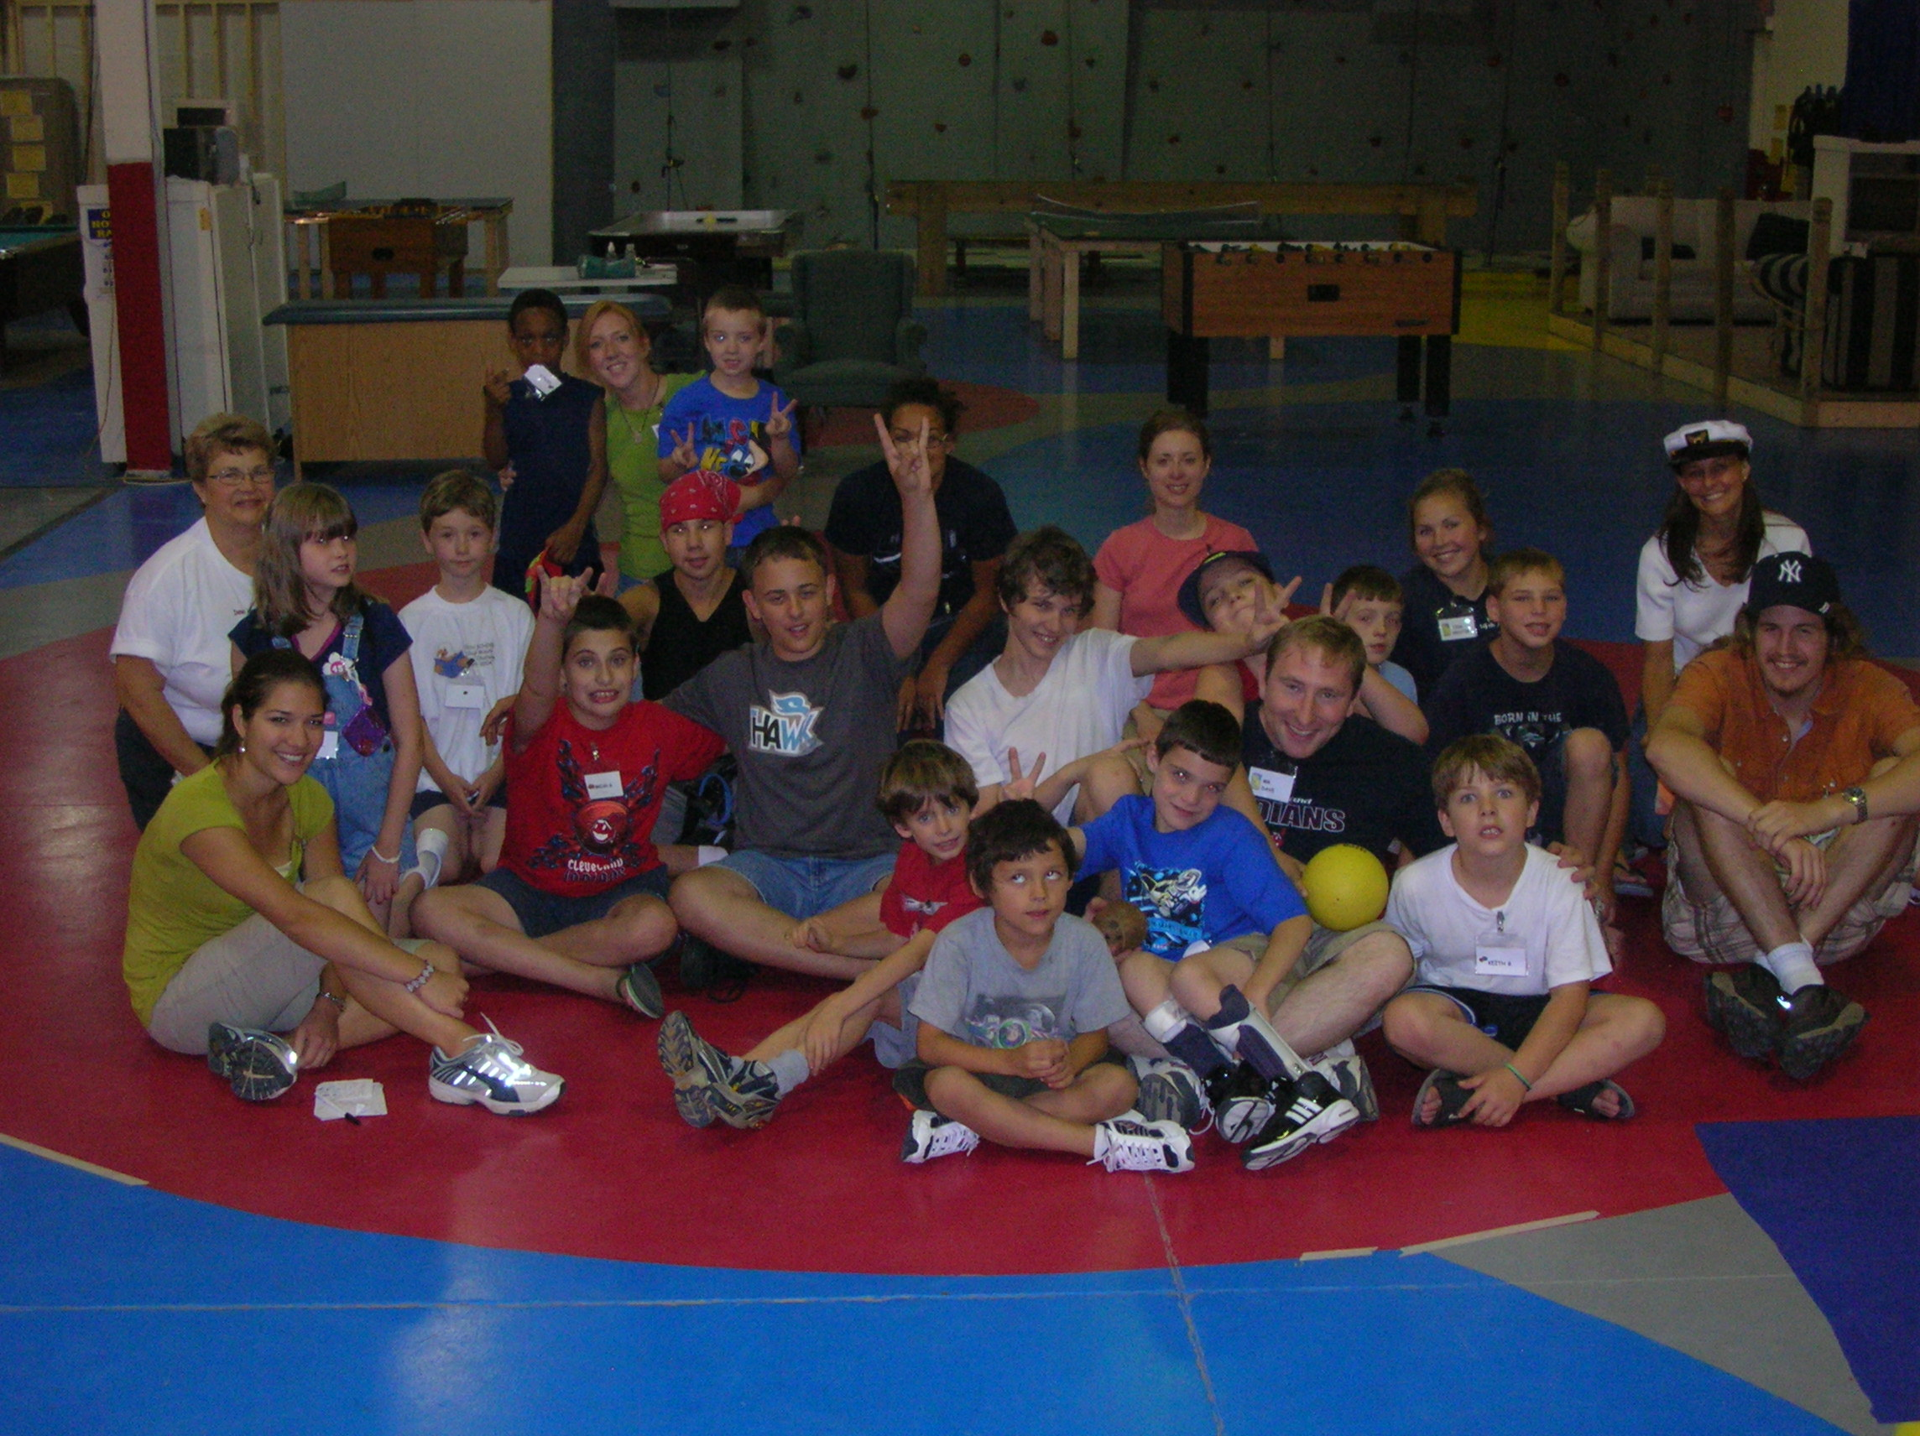
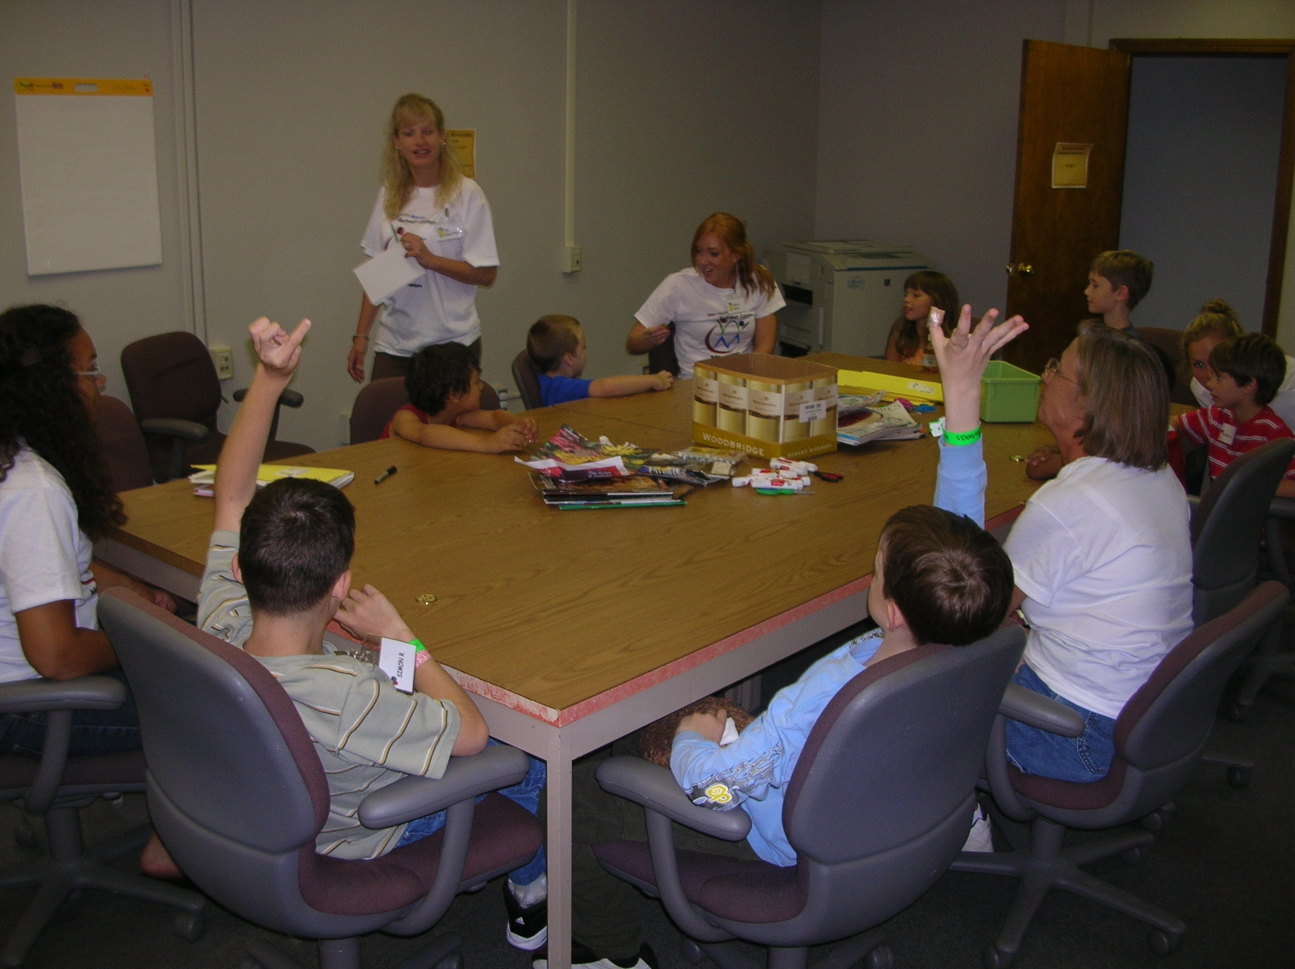
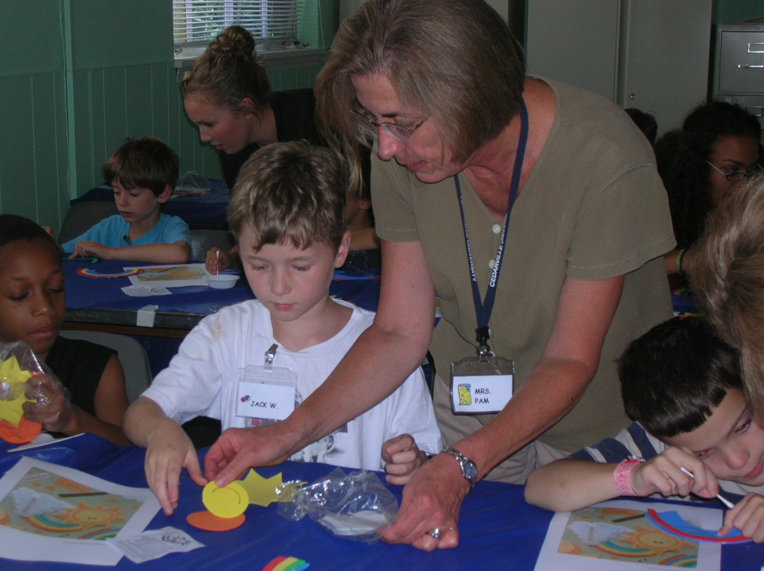

Caring Staff

Learning New Skills

Art Activities

Making Friends
- YES! I would like to donate to IHM Retreat Center. Enclosed is my gift of $________.
Bronze/Copper: $25/$50 gift = Newsletters Silver: $100 gift = Magnet Frame
Gold: $500 gift = Commemorative Engraving at Retreat Center Platinum: $1,000 gift = Building Memorial
€ Monthly Donation € Yearly Donation € One Time Donation
Name
Address
City State Zip Phone
My gift is in Memory or Honor of _______________________________________________________________.
You can also make donations online by visiting www.ihmretreat.org (credit cards accepted).
All Donations Are Tax Deductible.

IHM Retreat Center
17730 Lorain Road, Suite 7
Cleveland, Ohio 44111

Inner Health Ministries (IHM) Retreat Center is a Christian nonprofit 501(c)(3) organization committed to caring for the mental, physical, social, behavioral, and spiritual health of children, teenagers, and their families. Our mission is to provide wellness programs, classes, and retreats for families of children and adolescents with various medical conditions, pervasive developmental disorders, and other special needs. Children and families have the opportunity to experience Christ’s love through researched-based treatment programs, art activities, music, sports, health education, relationship building, and more.
www.ihmretreat.org

- YES! I would like to donate to IHM Retreat Center. Enclosed is my gift of $________.
Bronze/Copper: $25/$50 gift = Newsletters Silver: $100 gift = Magnet Frame
Gold: $500 gift = Commemorative Engraving at Retreat Center Platinum: $1,000 gift = Building Memorial
€ Monthly Donation € Yearly Donation € One Time Donation
Name
Address
City State Zip Phone
My gift is in Memory or Honor of _______________________________________________________________.
You can also make donations online by visiting www.ihmretreat.org (credit cards accepted).
All Donations Are Tax Deductible.

